DOCUMENT CREATION AND FORMATTING
Ex. No.: 1(a) Date: 27.11.2020
Exercise Name: Document Creation and Formatting
AIM:
To create a new document and format the text using any office automation tool
PROCEDURE: (Using Microsoft Office)
Step 1: To open a new word document select Start-> Microsoft office-> Microsoft word
Step 2: For the Text Formatting
Bold – Home-> Bold or (ctrl + b)
Italic – Home-> Italic or (ctrl + i)
Underline – Home-> Underline or (ctrl + u)
Cut – Home->cut or (ctrl + x)
Copy – Home-> Bold or (ctrl + c)
Paste – Home-> Bold or (ctrl + v)
Step 3: For the Text Alignment
Left alignment – ctrl+l
Right alignment – ctrl+r
Center alignment – ctrl+e
Justify alignment – ctrl+j

Step 4: For Page Setup
Margin setup – Page layout-> Margins
Page orientation – Page layout -> Orientation
Paper size – Page layout -> Size
Split the text into more columns – Page layout->Columns
Step 5: To insert a table select Insert->Table->Insert Table
Step 6:To insert a picture select Insert->Picture
Step 7: To insert a shapes select Insert->Shapes
Step 8: To insert a page number select Insert->Page Number
Step 9: To insert symbol select Insert->symbol
Step 10: To insert equations select Insert->Object->Microsoft Equation
Step 11: To save the document select File->Save
Step 12: To open an existing document select File->Open
Step 13: To close the document select File->Exit

SPREAD SHEET CREATION AND CALCULATION
Ex. No.: 2(a) Date: 4.12.2020
Exercise Name: Spread Sheet Creation and Calculation
AIM:
To create a new spread sheet and perform calculation using any office automation tool
PROCEDURE: (Using Microsoft Office)
Step 1: To open a new spreadsheet select Start-> Microsoft office-> Microsoft Excel
Step 2: To calculate the total use the function =sum(cell range)
Step 3: To calculate the average use the function =average(cell range)
Step 4: To calculate the minimum value use the function = min(cell range)
Step 5: To calculate the maximum value use the function =max(cell range)
Step 6: To ceil the floating point value use the function =ceiling(cell,significance)
Step 7: To round off the floating point value use the function
=round(cell, number of digits)
Step 8:To count the number of cells use the function=count(cell range)
Step 9: To count the number of cells with condition use the function
=countif(cell range, criteria)
Step 10: To insert a chart select Insert->Chart

POWER POINT PRESENTATION
Ex. No.: 3(a) Date: 11.12.2020
Exercise Name: Power Point Creation and Presentation
AIM:
To create a new power point presentation using any office automation tool
PROCEDURE: (Using Microsoft Office)
Step 1: To open a new power point presentation select Start-> Microsoft office->
Microsoft PowerPoint
Step 2: To create a new slide select Home->Slide (ctrl + m)
Step 3: To insert a video select Insert->Video
Step 4: To insert a audio select Insert->Audio
Step 5: To change the theme of the slide select Design->Office Theme

FLOWCHART  Ex. No.: 4(a)  Exercise Name: Flowchart for area of a circle AIM:  To draw the flowchart for area of a circle  ALGORITHM:  Area of a circle  Step 1: Start  Step 2: Read the value of r  Step 3: Calculate area = 3.14*r*r  Step 4:Print the value of area  Step 5: Stop  Flow chart:  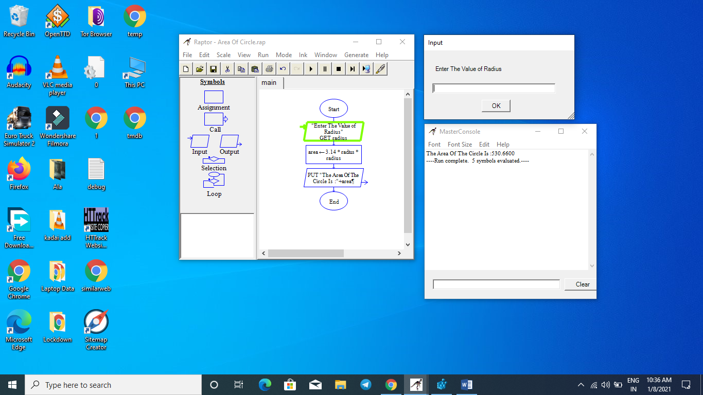 | Date: 18.12.2020
no.: 4(b)
Exercise Name: Flowchart for biggest among two numbers AIM:
To draw the flowchart for biggest among two numbers

ALGORITHM:
Biggest among two numbers
Step 1: Start
Step 2: Read two numbers for A and B
Step 3: Compare the value of A and B. If A is greater goto Step 4 else goto Step 5
Step 4: Output “A is greatest”
Step 5: Output “B is greatest”
Step 6: Stop
Flow chart:
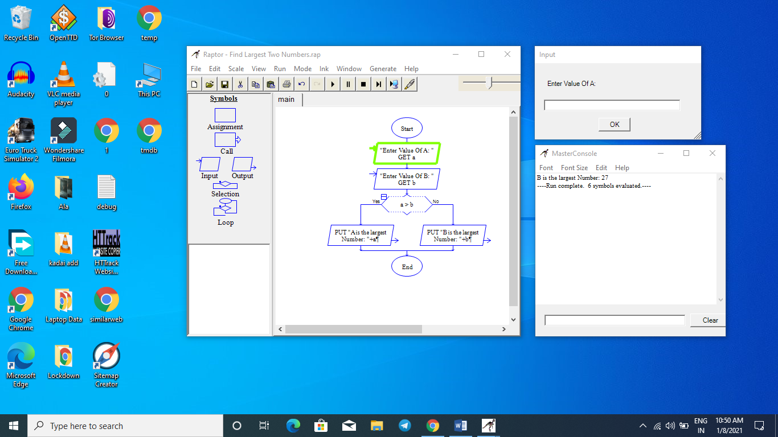

Ex. No.: 4(c)
Exercise Name: Flowchart for grade of the students
AIM:
To draw the flowchart for compute the grade of the students
ALGORITHM:
Step 9: Check if grade>9 if it is true goto Step 10 else goto Step 11
13

15

Grade of the student
Step 1: Start
Step 2:Read five integer marks for mark1, mark2, mark3, mark4, mark5
Step 3: Calculate total=mark1+mark2+mark3+mark4+mark5
Step 4: Print total
Step 5: Calculate avg=total / 5
Step 6: Print avg
Step 7: Calculate grade=avg /10
Step 8: Print grade
Step9: Check if grade>9 0if it is true goto Step 10 else goto Step11
Step 10: Print O grade
Step 11:Check the condition grade>8 0if it is true goto Step 12 else goto Step13
Step 12: Print A+ grade
Step 13: Check the condition grade>70 if it is true goto Step 14 else goto Step

Step 14: Print A grade
Step 15: Check the condition grade>6 if it is true goto Step 16 else goto Step 17
Step 16: Print B grade
Step 17: Print Reapper
Step 18: Stop
Flow chart:
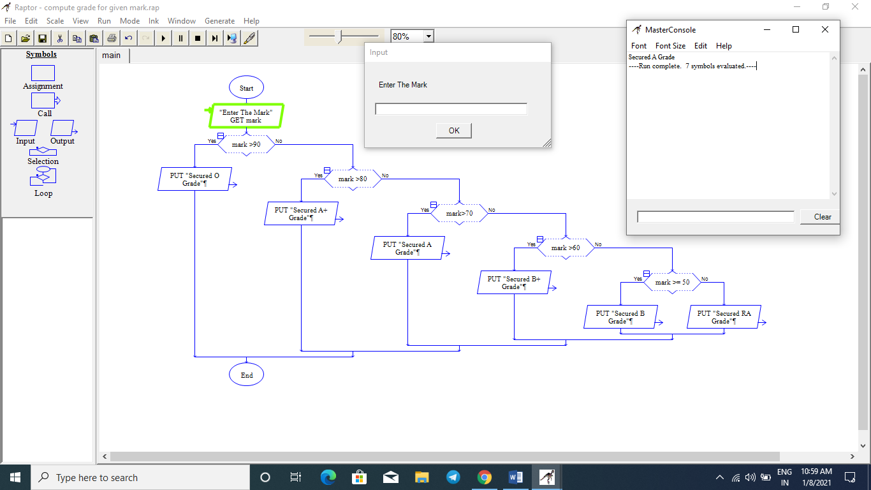

Ex No .: 4(d)
Exercise Name: Flowchart for sum and average of N numbers AIM:
To draw the flowchart to find the sum and average of N numbers
ALGORITHM:
Sum and Average of N numbers

Step 1: Start
Step 2: Read the value of n
Step 3: Assign the value of sum=0 and i=1
Step 4: Check the condition (i<=n). If the condition is true goto Step 5
else goto Step 7
Step 5: Assign sum = sum + i
Assign i = i +1
Step 6:Repeat the Step 5 until the condition is satisfied
Step 7: Compute avg = sum / n
Step 8: Print the value of sum and avg
Step 9: Stop
Flow chart:
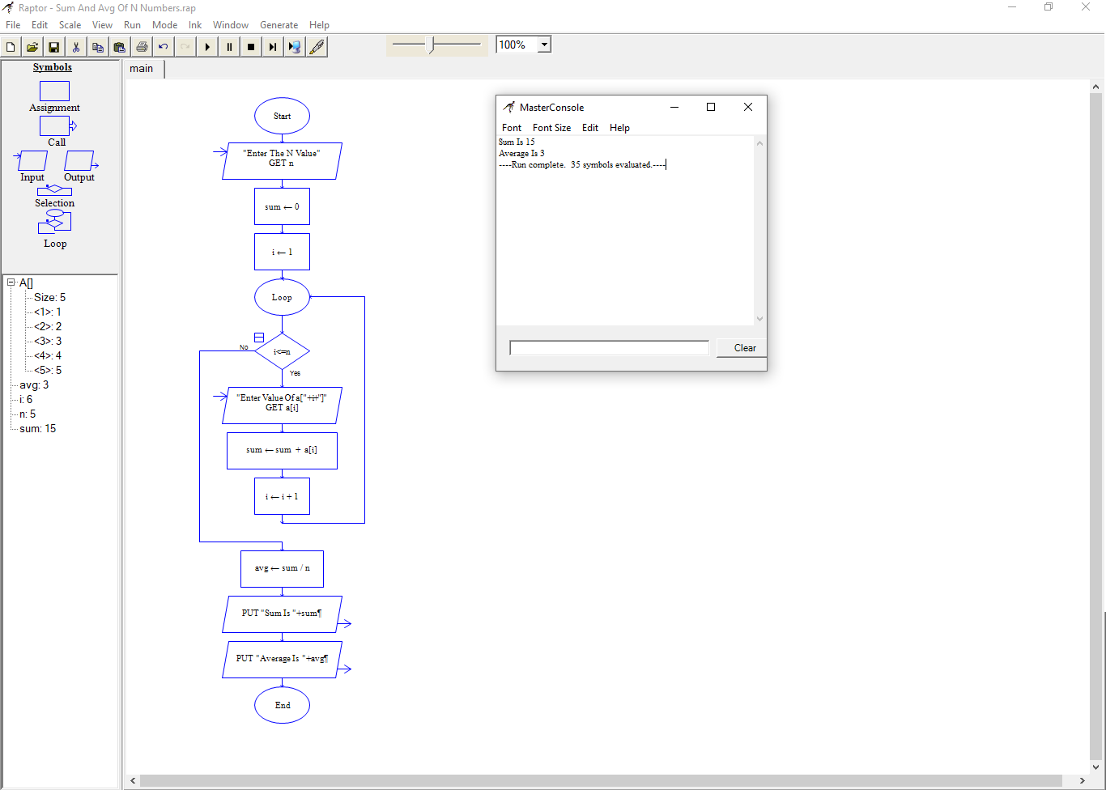

C PROGRAMS USING I/O STATEMENTS AND EXPRESSIONS
Ex. No.: 5(a)(i) Date: 8.1.2021
Program Name: Find the Area and Volume of Shapes
AIM:
To Write a C Program to find the area and volume of shapes
ALGORITHM:
Area of a Circle
Step 1: Start
Step 2: Read the value of r
Step 3: Calculate area = 3.14*r*r
Step 4: Print the value of area
Step 5: Stop
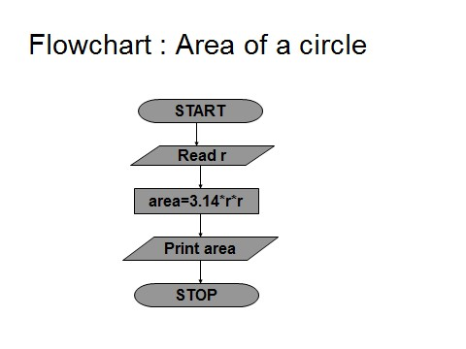
Program:
#include <stdio.h>
int main()
{
float r,a;
printf("enter the radius of circle:");
scanf("%f",&r);
a=3.14*r*r;
printf("the afrea of the circle is %f",a);
return 0;

}

Out put:

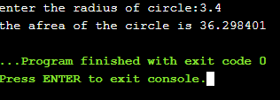
Area of a Rectangle
Step 1: Start
Step 2: Read the value of length and breadth
Step 3: Calculate area = length * breadth
Step 4:Print the value of area
Step 5: Stop
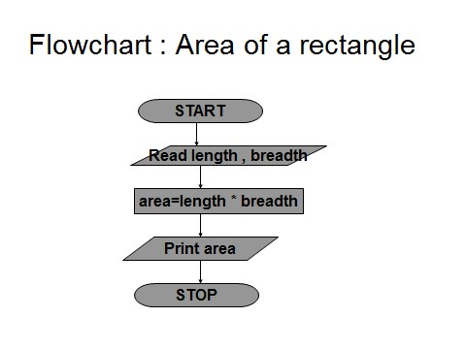

Program:
#include <stdio.h>

int main()
{
int l,b,a;
printf("enter the length and breath of the rectangle:");
scanf("%d %d",&l,&b);
a=l*b;
printf("the afrea of the circle is %d",a);
return 0;

}
Out put:
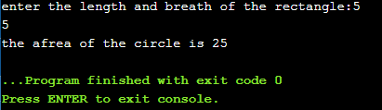

Area of a Triangle
Step 1: Start
Step 2: Read the value of base and height
Step 3: Calculate area = 0.5 * base * height
Step 4: Print the value of area
Step 5: Stop
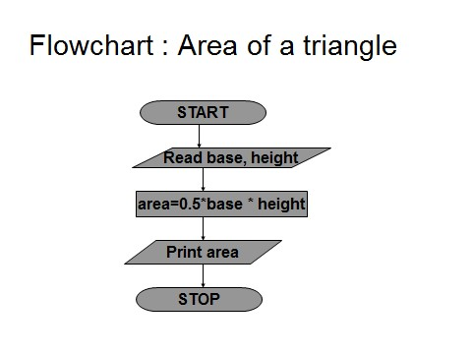
Program:

#include <stdio.h>

int main()
{
float a,h,b;
printf("enter the hight and breath of the triangle:\t");
scanf("%f %f",&h,&b);
a=h*b/2;
printf(" the area of the triangle is:%f",a);
return 0;
}

Out put:

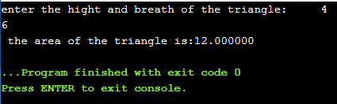

Area of a Square
Step 1: Start
Step 2: Read the value of side
Step 3: Calculate area = side * side
Step 4: Print the value of area
Step 5: Stop
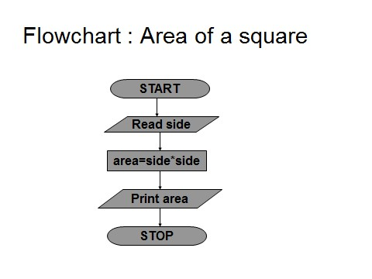
Program:
#include <stdio.h>

int main()
{
int a,b;
printf("enter the sides of the square:\t");
scanf("%d",&b);
a=b*b;
printf(" the area of the square:%d",a);
return 0;
}
Out put:
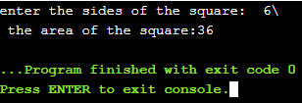

volume of a Cube
Step 1: Start
Step 2: Read the value of side
Step 3:Calculate volume = side * side * side
Step 4: Print the value of volume
Step 5: Stop
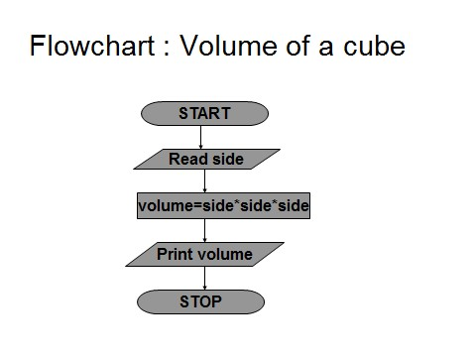

Program:
#include <stdio.h>
int main()
{
int a,b;
printf("enter the sides of the cube:\t");
scanf("%d",&b);
a=b*b*b;
printf(" the volume of the cube:%d",a);
return 0;
}
Out put
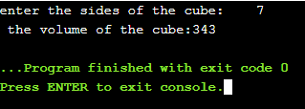

Ex No .: 5(b)
Convert Centigrade to Fahrenheit
AIM:
To Write a C Program to convert Centigrade to Fahrenheit
ALGORITHM:
Celsius to Fahrenheit
Step 1: Start
Step 2: Read the value of Celsius
Step 3: Calculate Fahrenheit = (1.8* Celsius) + 32
Step 4: Print the value Fahrenheit
Step 5: Stop
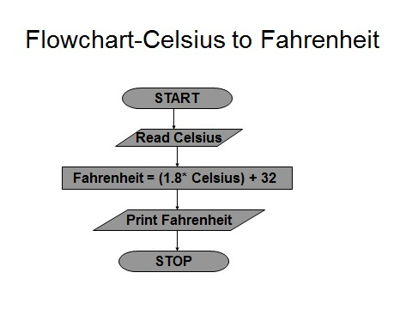

Program:

#include <stdio.h>
int main()
{
float cl,f;
printf("enter the celsius :\t");
scanf("%f",&cl);
f=(1.8*cl)+32;
printf(" \nthe farien heat is:%f",f);
return 0;
}
Out put
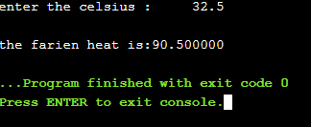

Ex No .: 5(c) (i)
Program Name: i) Swap two numbers using temporary variable
AIM:
To Write a C Program to swap two numbers using temporary variable
ALGORITHM:
Swap using temp variable
Step 1: Start the program
Step 2: Read the value of a and b
Step 3: Assign c = a
Assign a = b
Assign b = c
Step 4: Print the value of a and b
Step 5: Stop
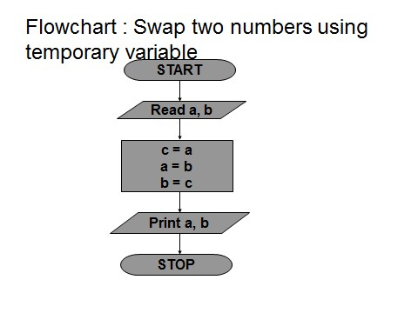
Program:
#include <stdio.h>
int main()
{
int a,b,temp;
printf("enter the no.1:\t");
scanf("%d",&a);
printf("\n\nenter the no.2:\t");
scanf("%d",&b);
temp=a;
a=b;
b=temp;
printf("the numbers after swaping is:\t%d\t%d",a,b);
return 0;
}

Out put
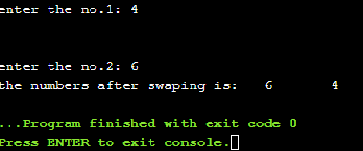

Ex No.: 5(c)(ii)
ii) Swap two numbers without using temporary variable
AIM:
To Write a C Program to swap two numbers without using temporary variable
ALGORITHM:
Swap without temp variable
Step 1: Start
Step 2: Read the value of a and b
Step 3: Assign a = a + b
Assign b = a - b
Assign a = a - b
Step 4: Print the value of a and b
Step 5: Stop
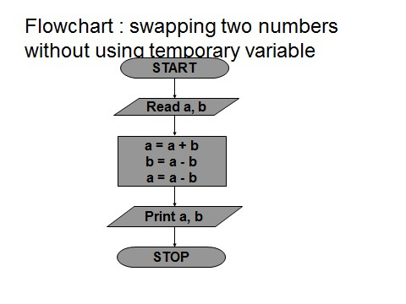

Program:
#include <stdio.h>
int main()
{
int a,b;
printf("enter the no.1:\t");
scanf("%d",&a);
printf("\n\nenter the no.2:\t");
scanf("%d",&b);
a=a+b;
b=a-b;
a=a-b;
printf("the numbers after swaping is:\t%d\t%d",a,b);
return 0;
}
Out put
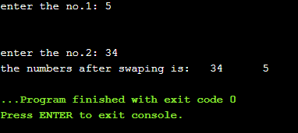

C PROGRAMS USING DECISION MAKING CONSTRUCTS
Ex. No.: 6(a) Date: 11.1.2021
Program Name: Find the Biggest among two numbers
AIM:
To Write a C Program to find the biggest among two numbers
ALGORITHM:
Biggest among two numbers
Step 1: Start
Step 2: Read two numbers for a and b
Step 3: Compare the value of a and b. If a is greater goto Step 4 else goto Step 5
Step 4: Output “a is greatest”
Step 5: Output “b is greatest”
Sep 6 : Stop
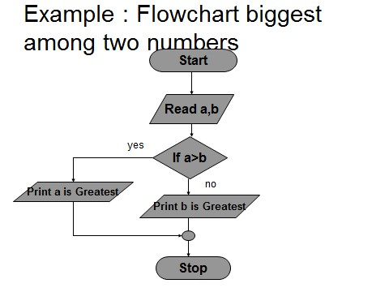
Program:
#include <stdio.h>
int main()
{
int a,b;
printf("enter the no.1:\t");
scanf("%d",&a);
printf("\n\nenter the no.2:\t");
scanf("%d",&b);
if (a>b)
printf("a is greater");
else
printf("b is greater");
return 0;
}
Out put
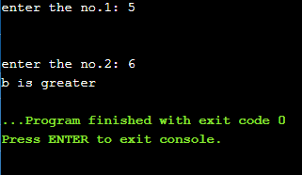

Ex No .: 6(b)
Check the given year is leap year or not
AIM:
To Write a C Program to check the given year is leap year or not
ALGORITHM:
Check the given year is Leap year or not.

Step 1: Start
Step 2: Read the value for year
Step 3: Check (year%400=0) or (year%4=0 and year%100=0), If the condition is true perform Step 4 else perform Step 5
Step 4: Print year is leap year
Step 5: Print year is not a leap year
Step 6: Stop
FLOWCHART FOR LEAP YEAR

True

False

Print

Read year

IS (iyear%400=0)or

iyear%100=0 and
(
iyear%4
=0
)

Print year is
leap y
ear.

Print year is not
a leap year.

Start

Stop

Program
#include <stdio.h>
int main()
{
int y;
printf("enter the year:\t");
scanf("%d",&y);
if ((y%4==0)&&y%100!=0||y%400!=0)
printf("the year is leap year",y);
else
printf("the year is not leap year",y);
return 0;
}

Out put
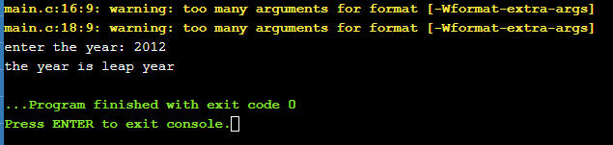

Ex. No.: 6(c) Date:
Program Name: Compute grade for given marks
AIM:
To Write a C Program to compute the grade for given marks
ALGORITHM:
Grade of the student
Step 1: Start
Step 2: Read five integer marks for mark1, mark2, mark3, mark4, mark5
Step 3: Calculate total=mark1+mark2+mark3+mark4+mark5
Step 4: Print total
Step 5: Calculate avg=total / 5
Step 6: Print avg
Step 7: Calculate grade=avg /10
Step 8: Print grade

Step 9: Check if grade>9 if it is true goto Step 10 else goto Step 11

Step 10: Print O grade
Step 11: Check the condition grade>8 if it is true goto Step 12 else goto Step 13

Step 12: Print A+ grade

Step 13: Check the condition grade>7 if it is true goto Step 14 else goto Step 15
Step 14: Print A grade
Step 15: Check the condition grade>6 if it is true goto Step 16 else goto Step 17
Step 16: Print B grade

Step
17:

Print Reap
per

Step

18:

Stop

FLOW CHART : Student Grade

True

False

True

False

True
False

True

False

True

Start

Read
mark1,
mark2,
mar
k
3
,mark4,
mark
total = mark1+mark2+mark3+mar4+mark5

avg=total/5

grade
9

>

Print

O grade

Print

A+ grade

grade
8
>

grade

>
7

Print

A

grade

g
rade
>

6

Print

B
+

grade

grade
>
=5

Print

B
grade

Print

Reappear

Stop

False

Program
#include <stdio.h>
int main()
{
int a, b;
printf("Enter the Value Of no.1 and no.2: ");
scanf("%d %d", &a, &b);
if(a>b)
{
printf("%d is The Biggest Number", a);
} else
{
printf("%d is The Biggest Number", b);
}
return 0;
}
Output
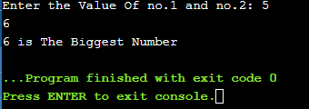

C PROGRAMS USING LOOPING CONSTRUCTS
Ex. No.: 7(a) Date: 22.1.2021
Program Name: Find the Sum and Average of N Numbers
AIM:
To Write a C Program to find the sum and average of N Numbers
ALGORITHM:
Sum and Average of N numbers

Step 1: Start
Step 2: Read the value of n
Step 3: Assign the value of sum=0 and i=1
Step 4: Check the condition (i<=n). If the condition is true goto Step 5
else goto Step 7
Step 5: Assign sum = sum + i
Assign i = i +1
Step 6: Repeat the Step 5 until the condition satisfied
Step 7: Compute avg = sum / n
Step 8:Print the value of sum and avg
Step 9: Stop
FLOWCHART: SUM AND AVERAGE OF N NUMBERS
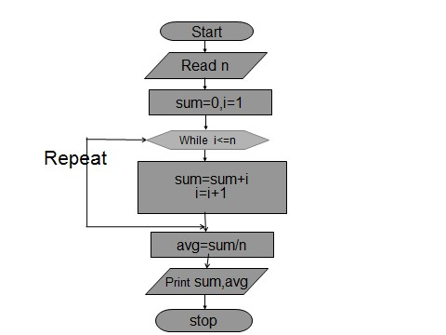

Program
#include<stdio.h>
int main() {
int i,n,Sum=0,numbers;
float Average;
printf("\nenter thw number of ingetrs:\n");
scanf("%d",&n);
printf("\n Enter the elements one by one\n");
for(i=0;i<n;++i) {
scanf("%d",&numbers);
Sum = Sum +numbers;
}
Average = Sum/n;
printf("\nSum of the %d Numbers = %d",n, Sum);
printf("\nAverage of the %d Numbers = %.2f",n, Average);
return 0;
}
Out put
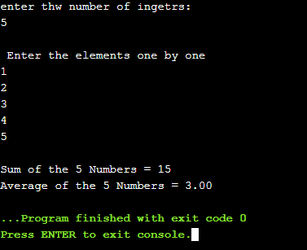

Ex. No.: 7(b)
Program Name: Find the given number is Armstrong number or not
AIM:
To Write a C Program to find the given number is Armstrong number or not
ALGORITHM:
Armstrong number checking for three digits
Step 1: Start
Step 2: Read the value of n
Step 3:Assign the value sum = 0, temp=n
Step 4: Check the condition n>0, If the condition is true goto Step 5 else goto Step7
Step 5: Assign rem = n % 10
Assign sum = sum + rem*rem*rem
Assign n = n / 10
Step 6: Repeat the Step 5 until the condition satisfied
Step 7: Check sum = temp, If the condition is true goto Step 8 else goto Step 9
Step 8: Print Armstrong
Step 9: Print Not Armstrong
Step 10: Stop
Flowchart for Armstrong number Checking
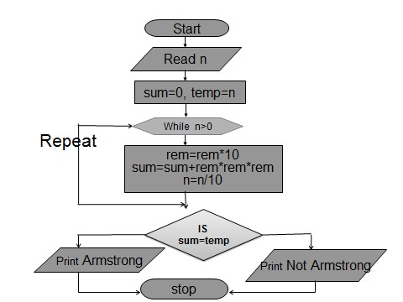

Program
#include <stdio.h>
int main() {
int num,r,sum=0,temp;
printf("Enter A Number: ");
scanf("%d",&num);
for(temp=num;num!=0;num=num/10){
r=num % 10;
sum=sum+(r*r*r);
}
if(sum==temp) {
printf("%d is an Armstrong number.\n",temp);
} else {
printf("%d is not an Armstrong number.\n",temp);
}
return 0;
}

Output
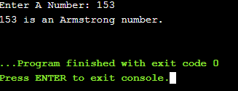

C PROGRAMS USING ONE DIMENSIONAL ARRAY
Ex. No.: 8(a) Date:29.1.2021
Program Name: Perform Linear Search
AIM:
To Write a C Program to perform linear search in 1D array elements.
ALGORITHM:
Step 1: Start
Step 2:Input array elements.
Step 3: Begin with the leftmost element of array[] and compare keynum with each element of the array.
Step 4: If keynum matches with an element then return the index.
Step 5: If keynum does not match with any of the elements then print the message element is not present in the array.
Step 6: Stop
Program
#include<stdio.h>
int main(){
int arr[10], num, i, n, found = 0, pos = -1;
printf("\nEnter the number of elements in the array: ");
scanf("%d",&n);
for(i = 0; i < n; i++) {
printf("\nEnter the elements %d: ",i+1);
scanf("%d",&arr[i]);
}
printf("\nEnter the number that has to be searched: ");
scanf("%d",&num);
for(i = 0; i < n; i++) {
if(arr[i] == num) {
found = 1;
pos = i;
printf("\n %d is found in the array at position = %d", num, i);
break;
}
}
if(found==0) {
printf("\n %d does not exist in the array", num);
}
return 0;
}
Output
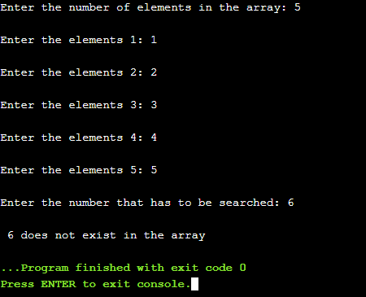

Ex. No.: 8(b)
Program Name: Bubble Sort
AIM:
To Write a C Program to sort the 1D array elements using bubble sort.
ALGORITHM:
Step 1: Start
Step 2: Input array elements.
Step 3: Starting with the first element (index = 0), compare the current element with the next element of the array.
Step 4: If the current element is greater than the next element of the array, swap them.
Step 5: If the current element is less than the next element, move to the next element. Repeat Step 3 till all the array elements are sorted in ascending order.
Step 6: Print the sorted array elements.
Step 7: Stop
Program
#include <stdio.h>
int main()
{
int array[100], n, i, j, temp;
printf("Enter number of elements\n");
scanf("%d", &n);
printf("Enter %d integers\n", n);
for (i = 0; i < n; i++)
{
scanf("%d", &array[i]);
}
for (i = 0 ; i < n - 1; i++)
{
for (j = 0 ; j < n - i - 1; j++)
{
if (array[j] > array[j+1])
{
temp = array[j];
array[j] = array[j+1];
array[j+1] = temp;
}
}
}
printf("Sorted list in ascending order:\n");
for (i = 0; i < n; i++) {
printf("%d\n", array[i]);
}
return 0;
}
Out put
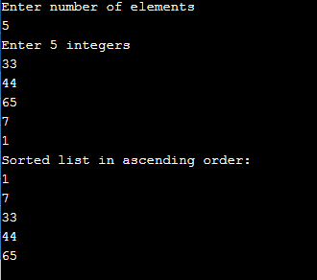

Ex. No.: 8(c) Date:
Program Name:Count the number of persons greater than averageheight
AIM:
To Write a C Program to populate an array with height of persons and find how many persons are above the average height
ALGORITHM:
Step 1: Start
Step 2: Take the height of persons as input to an array.
Step 3: Using for loop calculate the sum of heights of N persons.
Step 4: At the exit of for loop calculate the average of heights of N persons. Step 5: Compare average height with height of all the persons in the array, if height of a person is greater than the average height increment the counter value by one or else compare it with the next height.
Step 6: At the exit of the loop display the number of persons greater than the average height.
Step 7: Stop
Program
#include <stdio.h>
int main()
{
int array[100], i, n;
float avg = 0;
printf("Enter number of elements\n");
scanf("%d", &n);
printf("Enter %d integers\n", n);
for (i = 0; i < n; i++) {
scanf("%d", &array[i]);
avg += array[i];
}
avg = avg / n;
printf("Values More Than Avg Are: ");
for (int i = 0; i < n; i++)
if (array[i] > avg)
printf("%d, ", array[i]);
return 0;
}
Out put
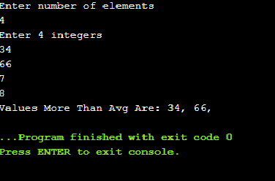

C PROGRAMS USING TWO DIMENSIONAL ARRAY
Ex. No.: 9(a) Date: 5.2.2021
Program Name: Add two matrices
AIM:
To Write a C Program to add 2D array matrix elements.
ALGORITHM:
Step 1: Start
Step 2: Input matrix 1 and matrix 2 elements.
Step 3: If the number of rows and number of columns of matrix 1 and matrix 2 are equal then execute Step 4 else print addition not possible
Step 4: for i=1 to rows[matrix 1] for j=1 to columns [matrix 1]
Input matrix 1 [i,j] Input matrix 2 [i,j] matrix 3 [i,j]= matrix 1 [i,j] + matrix 2 [i,j];
Step 5: Display matrix 3 [i,j]
Step 6: Stop

Program
#include <stdio.h>
int main(){
int r, c, mat1[100][100], mat2[100][100], sum[100][100], i, j;
printf("\nEnter the number of rows and columns : ");
scanf("%d %d", &r, &c);
printf("\nInput Matrix 1 elements : ");
for(i=0; i<r; ++i) {
for(j=0; j<c; ++j) {
scanf("%d",&mat1[i][j]);
}
}

printf("\nInput Matrix 2 elements : ");
for(i=0; i<r; ++i) {
for(j=0; j<c; ++j) {
scanf("%d", &mat2[i][j]);
}
}
printf("\nAdded Matrix\n");
for(i=0;i<r;++i) {
for(j=0;j<c;++j) {
sum[i][j]=mat1[i][j]+mat2[i][j];
printf("%d\t",sum[i][j]);
}
printf("\n");
}
return 0;
}
Out put
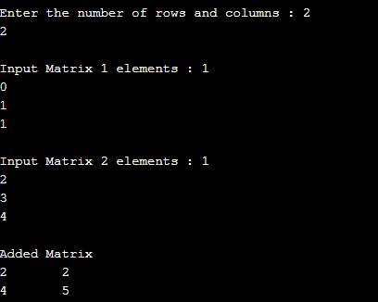

Ex. No.: 9(b)
Program Name: Multiply two matrices
AIM:
To Write a C Program to multiply 2D array matrix elements.
ALGORITHM:
Step 1: Start
Step 2: Input matrix a and matrix b.
Step 3: Number of columns in the matrix a must be equal to the number of rows in the matrix b. If the condition true then executes Step 4 else print multiplication not possible Step 4: fori=1 to rows[matrix a] for j=1 to columns [matrix b] for j=1 to columns [matrix b]
Input matrix a [i,j] Input matrix b [i,j] matrix c [i,j]= matrix c[i,j] + matrix a [i,k] * matrix b [k,j];
Step 5: Display matrix c[i,j]
Step 6: Stop
Program
#include <stdio.h>
int main(){
int r, c, mat1[100][100], mat2[100][100], sum[100][100], i, j;
printf("\nEnter the number of rows and columns : ");
scanf("%d %d", &r, &c);
printf("\nInput Matrix 1 elements : ");
for(i=0; i<r; ++i) {
for(j=0; j<c; ++j) {
scanf("%d",&mat1[i][j]);
}
}

printf("\nInput Matrix 2 elements : ");
for(i=0; i<r; ++i) {
for(j=0; j<c; ++j) {
scanf("%d", &mat2[i][j]);
}
}
printf("\nMultiplication of Matrix\n");
for(i=0;i<r;++i) {
for(j=0;j<c;++j) {
sum[i][j]=0;
for(int k=0;k<r;k++) {
sum[i][j] = sum[i][j] + mat1[i][k] * mat2[k][j];
}
printf("%d\t",sum[i][j]);
}
printf("\n");
}
return 0;
}

Output

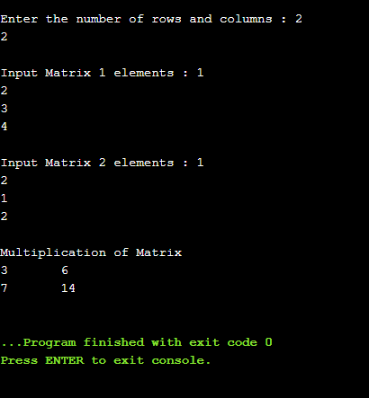

Ex. No.: 9(c) Date:
Program Name:Sum of diagonal elements of a matrix
AIM:
To Write a C Program to find Sum of diagonal elements of a matrix.
ALGORITHM:
Step 1: Start
Step 2: Input a matrix. for i=1 to rows[matrix a] for j=1 to columns [matrix b]
Input matrix[i,j]
Step 3: for i=1 to rows[matrix a] for j=1 to columns [matrix b] if i = = j then sum=sum + matrix[i][j]
Step 4: Display sum of diagonal elements of a matrix.
Program:
#include <stdio.h>
int main(){
int r, c, mat[100][100], i, j, sum = 0;
printf("\nEnter the number of rows and columns : ");
scanf("%d %d", &r, &c);
printf("\nEnter The Matrix elements : ");
for(i=0; i<r; ++i) {
for(j=0; j<c; ++j) {
scanf("%d",&mat[i][j]);
}
}

for(i=0;i<r;++i) {
sum = sum + mat[i][i];
}

printf("\n The Sum of Diagonal Elements of a Matrix = %d", sum );
return 0;
}

Output

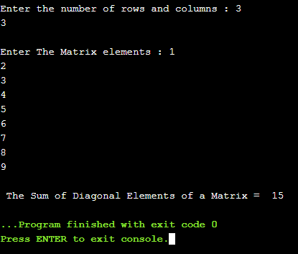

C PROGRAMS USING STRINGS
Ex No .: 10(a) Date :
Program Name: Check whether the given string is palindrome or not
AIM:
To Write a C Program to Check whether the given string is palindrome or not.
ALGORITHM:
Step 1: Start
Step 2: Read the entered string using gets(s).
Step 3: Calculate the string length using string library function strlen(s) and store the length into the variable n.
Step 4: Seti=0,c=0 and Compare the element at s[i] with the element at s[n-i-1].
If both are equal then increase the c value.
Step 5: Compare the remaining characters by increasing i value up to i< n / 2. Step 6: If the number of characters compared is equal to the number of characters matched then the given string is the palindrome.
Step 7: Stop
Program:

.: 10(b)
Program Name: Perform the following using built in functions:
- Find the total number of words.
- Capitalize the first word of each sentence.
AIM:
To Write a C Program to find the total number of words and Capitalize the first word of each sentence.
ALGORITHM:
- Count total number of words
Step 1: Start
Step 2: Read the entered string using gets(s).
Step 3: Setwordcount value to zero
Step 4: Traverse the string until the termination null character (\0)
Step 5: While traversing the characters in an array if str[i]==' ' or str[i]=='\n' increment wordcount counter value by 1.
Step 6: At the exit of the loop print the wordcount counter value.
Step 7: Stop

.: 10(b)
ALGORITHM:
- Capitalize the first word of each sentence.
Step 1: Start
Step 2: Read the entered string using gets(s).
Step 3: Traverse the string until the termination null character (\0)
Step 4:Within the loop if index position is 0 then change lowercase case character into upper case character using str[i]=str[i]-32 or check for space character in the string and convert the immediate character after space into uppercase character. Step 5: In a word if other than first character, if any character is in upper case then convert it into lower case character using str[i]=str[i]+32.
Step 6: At the exit of the loop print the string.
Step 7: Stop

C PROGRAMS USING FUNCTIONS
.: 11(a)
Arithmetic Calculator
AIM:
To write a C program to perform basic arithmetic operations using functions.
ALGORITHM:
Step 1: Start
Step 2: Input two numbers and a character from user in the given format. Store them in some variable num1, num2 and op.
Step 3: Switch the value of op i.e. switch(op). There are four possible values
of op i.e. '+', '-', '*' and '/'.
Step 4: For case '+' call addition function and return the result to main. In main function store the returned value in some variable.
Step 5: Repeat the process for subtraction, multiplication and division.
Step 6: Finally print the value of result.
Step 7: Stop

.: 11(b)
Program Name: Sorting N Numbers
AIM:
To write a C program to sort the list of numbers using functions.
ALGORITHM:
Step 1: Start
Step 2: Read the size of the array and store the value into the variable n.
Step 3: Read the entered elements one by one and store the elements in the array a[] using for loop.
Step 4: call the user defined function asc_sort()
Step 5: In the asc_sort( ) function arrange the array elements from least to highest value as for loop iterates from i=0 to i<n-1.
Step 7: Compare a[j] element with adjacent element a[j+1] and find the highest element then exchange the both elements positions using for loop.
Step 8: After all iterations of for loop, we will get sorted array in which the elements are in ascending order. Print the array elements using the for loop in the main function. Step 9: Stop

C PROGRAMS USING RECURSION
Ex. No.: 12(a) Date:
Program Name: Find the factorial of a number using recursion
AIM:
To write a C program to find the factorial of a number using recursion.
ALGORITHM:
Step 1: Start
Step 2: Read number num
Step 3: Call fact(num)
Step 4: Print factorial of a given number
Step 5: Stop

ALGORITHM FOR FUNCTION fact(n):
Step 1: If n==1 then return 1
Step 2: Else f=n*fact(n-1)
Step 3: Return f to main function

Ex. No.: 12(b) Date:
Program Name: Generate Fibonacci series using recursion
AIM:
To write a C program to generate Fibonacci series using recursion.
ALGORITHM:
Step 1: Start
Step 2: Read number of Fibonacci terms to be generated in n
Step 3: Call Fibanocci(num)
Step 4: Print the Fibonacci series
Step 5: Stop

ALGORITHM FOR FUNCTION Fibanocci(n):
Step 1: If num == 0 then return 0. Since Fibonacci of 0th term is 0.
Step 2: If num == 1 then return 1. Since Fibonacci of 1st term is 1.
Step 3: If num> 1 then return fibo(num - 1) + fibo(n-2). Since Fibonacci of a term is sum of previous two terms.

C PROGRAMS USING POINTERS
Ex. No.: 13(a) Date:
Program Name: Swap the value of two numbers using call by value andcall by reference
AIM:
To write a C program swap the value of two numbers using call by value and call by reference
ALGORITHM:
i) Swap two numbers using call by Value
Step 1: Start
Step 2: Input the values for a and b
Step 3: Call the function swap(&x,&y)
Step 3a: Start the function swap
Step 3b: Assign temp= *x
Step 3c: Assign *x = *y
Step 3d: Assign *y = temp
Step 3e: End function
Step 4: Print the value of a and b values in main function
Step 5: Stop

Ex. No.: 13(a)  ALGORITHM:  ii) Swap two numbers using call by Reference  Step 1: Start  Step 2: Input the values for a and b  Step 3: Call the function swap(&x,&y)  Step 3a: Start the function swap  Step 3b: Assign temp= *x  Step 3c: Assign *x = *y  Step 3d: Assign *y = temp  Step 3e: End function  Step 4: Print a and b values in main function  Step 5: Stop |  | Date:
Ex. No.: 13(b) Date:
Program Name: Sort a list of names using pointers
AIM:
To write a C program to sort a list of names using pointers.
ALGORITHM:
Step 1: Start
Step 2: Get number of strings as input from user in n
Step 3: Character array pointer type variable acquires thememoryusing malloc() function
Step 4: Call reorder(n,x)
Step 4.1: Traverse the Character array and compare the two consecutive strings using strcmp(x[i],x[j])>0 and if the condition is true then swap two strings.
Step 4.2: if strcmp(x[i],x[j])>0 is false then no need to swap the strings.
Step 5: Then traverse the character array and print the reordered strings in main() Step 6: Stop

C PROGRAMS USING STRUCTURES
Ex. No.: 14(a) Date:
Program Name: To compute internal marks of students for five
different subjects

AIM:
To write a C program to compute internal marks of students for five different subjects using structures.
ALGORITHM:
Step 1: Start
Step 2: Define a structure student using struct keyword.
Step 3: Create structure variables name, rollnumber and average marks within a structure.
Step 4: Create a variable for structure using as array of structures.
Step 5: Using the structure variable assign values for the variables within the structure.
Step 6: Display the students record of name, roll number and average marks using structure variable and .dot operator (eg: s.name)
Step 7: Stop

C PROGRAMS USING FILES
Ex. No.: 15(a) Date:
Program Name: To compute internal marks of students for five
different subjects
AIM:
To write a C program to compute internal marks of students for five different subjects using files.
ALGORITHM:
Step 1: Start
Step 2: Declare a file pointer variable using FILE *filepointer.
Step 3: Open a file using fopen() function in read, write or append mode and it returns the starting address of a file store it in file pointer location for further file processing.
Step 4: Get input from the file to the program using fscanf() and write the output onto the file using fprintf().
Step 5:Close the file using fclose(filepointer).
Step 6: Stop

CONTENT BEYOND SYLLABUS
AIM:
The objective of the puzzle is to move the entire stack to another rod, obeying the following simple rules:
- Only one disk can be moved at a time.
- Each move consists of taking the upper disk from one of the stacks and placing it on top of another stack i.e. a disk can only be moved if it is the uppermost disk on a stack.
- No disk may be placed on top of a smaller disk.
Algorithm
Step 1: Start
Step 2: Declare a tower_of_hanoi recursive function and pass two arguments: the number of disks n and the name of the rods such as source, temp, and target.
Step 3: Check the base case when the number of disks is one .If it is true goto
Step 4 else goto Step 5
Step 4: Simply move the one disk from the source to target and return.
Step 5: Recursively move remaining n-1 disks from source to temp using the target as the temp.
Step 6: Change the remaining one disk move on the source to target.
Step 7: Move the n-1 disks on the temp to the target using the source as the temp.
Step 8: Stop.

